I) Cách tạo 1 kết nối từ xa dùng ssh là sftp đến máy :

Yêu cầu: hdh có nhân linux của bạn( Để lưu 1 lượng lớn thông tin nhưng file ảnh, audio, ..)

Link tạo 1 kết nối sftp trên linux: (Đại khái nó là tạo 1 user sftp trên linu có thể dùng ssh để try cập linux của bạn) https://linuxhint.com/setup-sftp-server-ubuntu/

Step 1: Install SSH
sudo apt install ssh

Step 2: Change SSHD configuration for SFTP group
After installing the SSH, you need to change the ‘/etc/ssh/sshd_config’ SSHD configuration file. So, use nano editor or any other to open this configuration file as follows:
- sudo nano /etc/ssh/sshd_config
Now, paste the following lines at the end or bottom of the file:
Match group sftp
ChrootDirectory /home
X11Forwarding no
AllowTcpForwarding no
ForceCommand internal-sftp

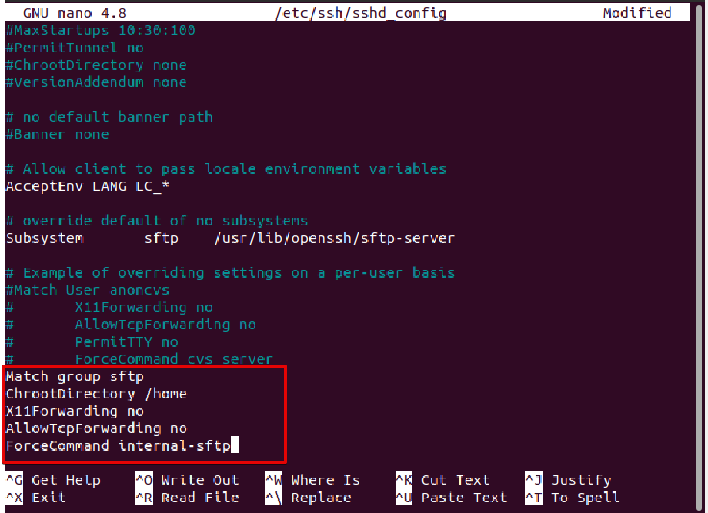
- sudo systemctl restart ssh

Step 3: Restart SSH services
For making the new changes to take effect, restart the SSH service using the ‘systemctl’ command:
- sudo systemctl restart ssh

Step 4: Create SFTP users group
To grant SFTP access to users, you will create SFTP user accounts. First, create a new user group for ‘SFTP’ users. For our convenience, all SFTP users will belong to the same group. So, run the below-mentioned command to create a new SFTP group:
$ sudo addgroup sftp

Step 5: Create a new SFTP user
Once the new group is added, create a new sftp user and then add this user into the sftp group by running the following command:
- sudo useradd -m sftp_user -g sftp

Set the password for the newly created sftp user by typing the following command:
- sudo passwd sftp_user
ở bước này thì có thể nó không set up đc password do lỗi gì đó

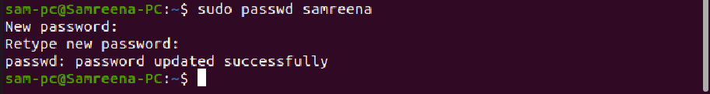

Step 6: Grant permissions to the specific directory
In this step, you grant full permissions to the sftp user on their home directory. But, other users on the system are not allowed to access this directory. So, grant access using the ‘chmod’ command as follows:
$ sudo chmod 700 /home/sftp_user/

Method 1: Connect to the SFTP using the command line

To connect Sftp by command line
sftp sftp_user@127.0.0.1

Method 2: Connect to the SFTP using the GUI
You can connect to the SFTP server using the GUI SFTP client application. You can either connect with the preferred SFTP client or use the built-in default Ubuntu Nautilus file manager.
Open the Nautilus file manager using the application menu and then click on the ‘other Locations’. Now, at the bottom of the current window, enter ‘sftp://127.0.0.1’ in the connect to server box and then click on ‘connect’.
Enter the SFTP account credentials which you have been set up above and click on the connect as follows:
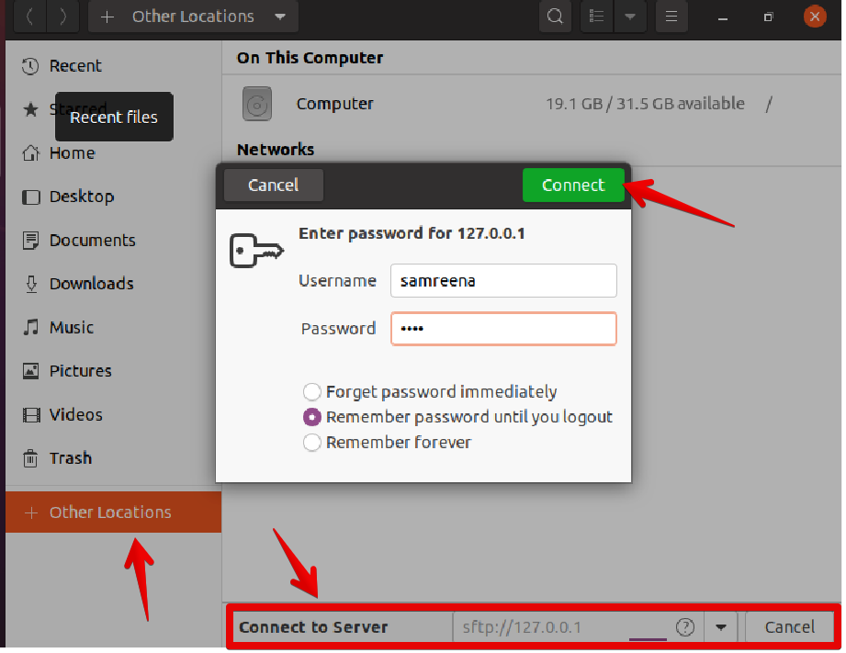
Thao tác với SFTP

Link thì ở đây: https://linuxize.com/post/how-to-use-linux-sftp-command-to-transfer-files/#sftp-commands
- sftp remote_username@server_ip_or_hostname

If the remote SSH server is not listening on the default port 22 , use the -P option to specify the SFTP port:
- sftp -P custom_port remote_username@server_ip_or_hostname

Transferring Files with SFTP
SFTP allows you to transfer files between two machines securely.
If you are working on a desktop machine, you can use a GUI SFTP client like WinSCP or FileZilla to connect to the remote server and download or upload files.
The sftp command is useful when you work on a server without GUI, and you want to transfer files or perform other operations on the remote files.

Downloading Files with the SFTP Command
To download a single file from the remote server, use the get command:
sftp> get filename.zip
The output should look something like this:

Fetching /home/remote_username/filename.zip to filename.zip
/home/remote_username/filename.zip 100% 24MB 1.
When downloading files with sftp, the files are downloaded to the directory from which you typed the sftp command.
If you want to save the downloaded file with a different name, specify the new name as the second argument:
get filename.zip local_filename.zip
To download a directory from the remote system, use the recursive -r option:
get -r remote_directory

Uploading Files with the SFTP Command
To upload a file from the local machine to the remote SFTP server, use the put command:
put filename.zip
The output should look something like this:
Uploading filename.zip to /home/remote_username/filename.zip
filename.zip 100% 12MB 1.7MB/s 00:06
If the file you want to upload is not located in your current working directory, use the absolute path to the file.
When working with put you can use the same options that are available with the get command.
To upload a local directory, you would type:
put -r locale_directory
To resume an interrupted upload:
reput filename.zip

